Solar Panel Power Output Simulation

HT NO:24705A0239

**• Models PV panel under different irradiance & temperature**

**• Inputs: Solar irradiance, temperature**

**• Outputs: I–V and P–V characteristics, max power point**

**• Libraries: numpy, matplotlib**

**• Application: Renewable energy system design**

Programe:

import numpy as np

import matplotlib.pyplot as plt

# Constants

q = 1.6e-19   # Charge of electron (C)

k = 1.38e-23  # Boltzmann constant (J/K)

T = 298       # Temperature in Kelvin (25°C)

n = 1.3       # Ideality factor

Iph = 5       # Photo current (A)

Io = 1e-10    # Saturation current (A)

Rs = 0.01     # Series resistance

Vt = (k * T) / q

# Voltage range

V = np.linspace(0, 0.7, 100)

# Current equation (simplified diode model)

I = Iph - Io * (np.exp((V + Iph * Rs) / (n * Vt)) - 1)

# Power

P = V * I

# Plot I-V curve

plt.figure()

plt.plot(V, I, label="I-V Curve")

plt.xlabel("Voltage (V)")

plt.ylabel("Current (A)")

plt.title("Solar Panel I-V Characteristics")

plt.grid(True)

plt.legend()

plt.show()

# Plot P-V curve

plt.figure()

HT NO:24705A0239

plt.plot(V, P, label="P-V Curve", color="orange")

plt.xlabel("Voltage (V)")

plt.ylabel("Power (W)")

plt.title("Solar Panel P-V Characteristics")

plt.grid(True)

plt.legend()

plt.show()

OUTPUT:

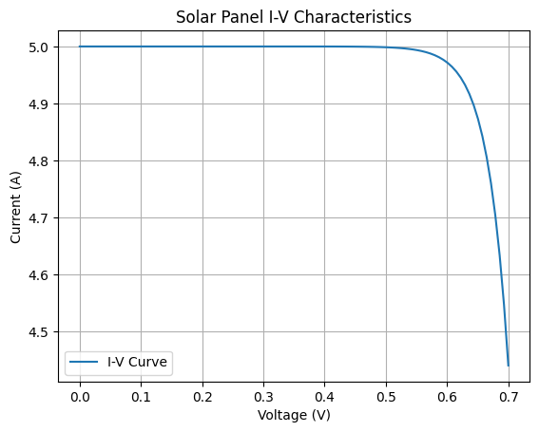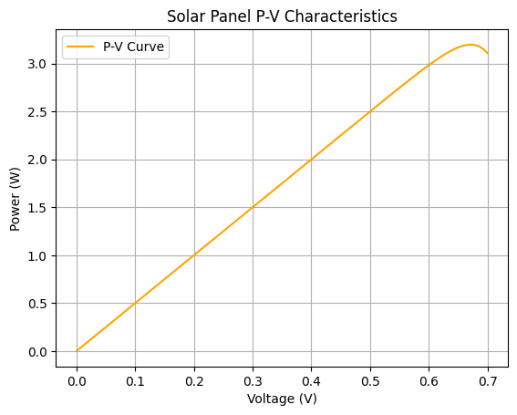

Conclusion:

The simulation shows that solar panel output depends on irradiance and temperature. Higher irradiance increases current and power, while higher temperature reduces voltage and efficiency. The I–V and P–V curves clearly identify the Maximum Power Point (MPP), which is important for renewable energy system design.